
NATIONAL SKILLS UNIVERSITY
Faiz Ahmed Faiz Road, H-8/1, Islamabad
*****
Assignment: 03
Course Title: Data Structures and Algorithms Semester: Fall 2025
Student Name: ______________________________ Date:
Registration No.: _____________________________ Total Marks:

Deadline: 7th January, 2026
Covered CLO: , Covered PLOs: PLO
Note: Submit your assignments on proper sheets and it should be neat and clean
Question 1:
Add elements in the following order; do the appropriate rotations when needed.
- 1 2 3 4 5 6 11 13 12 10 9 8 7
Question 2:
Construct AVL Tree for the following sequence of numbers-
- 60,30,70,20,18,25,42,56,21,58
Question 3:
Insert the following sequence of elements into an AVL tree, starting with an empty tree:
- 30,40,35,45,50,36,38,39
Question 4:
Insert 7 in the given binary search tree. And check if any rotation is required in it to make it balance. If “No”, just insert 7.
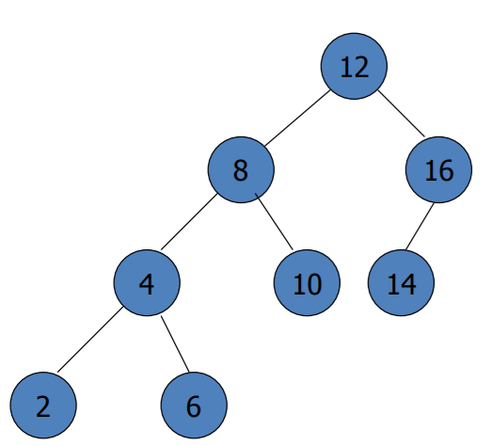
Question 5:
Compare the complexity of insertion and deletion in Binary search tree and AVL tree

